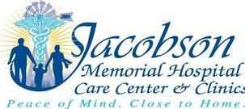
Implementation Strategy Planning Report
Jacobson Memorial Hospital Care Center
Facilitated by
Ken Hall
Tiffany Knauf
Center for Rural Health
The University of North Dakota School of Medicine and Health Sciences
Funded by
TheDepartment of Health and Human Services,
Health Resources and Services Administration, Federal Office of Rural Health Policy, North Dakota Medicare Rural Hospital Flexibility Grant Program
Introduction

Jacobson Memorial Hospital Care Center& Clinics (JMHCC),which includes a Critical Access Hospital (CAH), held a strategic planning workshop in Elgin on June 3, 2014 as part of a meeting about a Community Health Needs Assessment (CHNA) that was conducted in Grant County. JMHCC collaborated with Custer Health, the local public health unit, in conducting the assessment.Two representatives from the Center for Rural Health at the University of North Dakota School of Medicine and Health Sciences facilitated the meeting, which was attended by 13 community members, including members of the hospital’s administrative staff.
The strategic planning workshop was a continuation of the overall CHNA process, which is a requirement of the Affordable Care Act (ACA). The legislation mandates that non-profit hospitals conduct a CHNAat least every three years, examine input from community representatives, publicly disseminate the results, prioritize community health needs, and develop a written implementation strategy (a health improvement plan) to help meet the needs identified in the CHNA. With assistance from the Center for Rural Health, JMHCC conducted the needs assessment portion of the process throughout the spring of 2014.

The purpose of the workshop was to initiate a more formalized strategic planning process resulting in a written implementation strategy to help address the identified significant community health needs. Strategic planning is a technique to assist a group to analyze current conditions and then develop strategies to address a set of issues and/or concerns. Workshop facilitators used a logic model as a framework for evaluating, analyzing, and organizing ideas to address the enumerated significant needs. Logic models are widely practiced in social science research to state future goals, outline responsibilities and actions needed to achieve the goals, and demonstrate a program’s progress.

To begin the strategic planning workshop, the facilitators from the Center for Rural Healthshared findings from theCHNA report with the workshop participants. Data analyzed during the CHNA process included primary data (a community health survey, focus group, and key informant interviews) and secondary data (analysis of County Health Rankings and other data sources). The corresponding PowerPoint presentation is attached as Appendix A.

Following the presentation of the assessment findings, and after consideration of and discussion about the findings, all members of the group were asked to identify what they perceived as the top five community health needs. All of the potential needs were listed on large poster boards, and each member was given five stickers to place by the five needs they thought were the most significant. Group members were advised they could consider a number of criteria when prioritizing needs, such as a need’s burden, scope, severity, or urgency, as well as disparities associated with the need and the overall importance the community places on addressing the need. The results were totaled, and the concerns most often cited were:
- Attracting and retaining young families (6 votes)
- Ability to retain doctors and nurses in the community (6 votes)
- Declining community engagement and cohesiveness (6 votes)
The next highest vote-getting issues, which each received four votes, were: (1) elevated rate of adult obesity, (2) limited access to exercise opportunities, (3) elevated rate of uninsured residents, and (4) not enough jobs with livable wages. Since there was some interrelatedness between the measures of adult obesity and lack of exercise opportunities (and since other related issues such as elevated rate of diabetics and elevated rate of physical inactivity each received three votes), the group decided to combine these concerns into an additional significant need, labelled healthy lifestyles. Thus, the community group determined that based on the information gathered in the CHNA process, the four significant needs facing the community were (in no particular order):

- Attracting and retaining young families
- Ability to retain doctors and nurses in the community
- Declining community engagement and cohesiveness
- Encouraging healthy lifestyles

Theworkshop then turned its focus to generating ideas and strategies to address the identified significant needs through a variety of approaches. Due to time constraints, the group decided to concentrate on two needs that evening, with the understanding that an additional session should be planned to brainstorm on the other two needs. The group worked on the needs of attracting and retaining young families and encouraging healthy lifestyles. To initiate the brainstorming process using the logic model, participants were presented with one of theneedsas the beginning point on a continuum. The end point was the outcome, or a vision of what the future would look like if that need was addressed. Participants were given sticky notes and asked to write down desired outcomes, that is, goalsor changes they would like to see related to this need. One facilitator organized the sticky notes into thematic categories and read them to the group as the other facilitator typed them into a laptop, and a table showing the logic model continuum was projected onto a screen so all could see. The outcomes were reviewed collectively so participants could discuss them.

Working backwards from the stated outcomes or goals, participants were then asked as a group to brainstorm activities that could help achieve the outcomes. Once a list of activities was produced and discussed, some resourceswere identified that might help in accomplishing the activities, including people, organizations, existing infrastructure and programs, and potential financial resources. Finally, to complete the logic model, a list of outputs, or evidence that the activity was accomplished, was discussed but not produced as the activity needs to be enacted first. The output columnin the table will be completed later. The brainstorming tables, in draft form, are included in this report for informational purposes as Appendix B.

Through collaborative brainstorming, participantsidentified clear and measurable action steps that can be taken to address the needs identified through the assessment. A further step of delineating who will responsible for what activity and assigning a timeline to the tasks will help convey ownership.

Priority Need #1: Attracting and Retaining Young Families
JMHCC does not intend to address this identified need directly because it lacks sufficient resources to address this need, lacks expertise to address this need, is not aware of effective interventions to address this need, and because the need is outside the scope of the hospital’s mission. JMHCC acknowledges that the community identified this issue as a priority need and will forward the information to other community stakeholders and organizations that may be better equipped to meet the need.
Priority Need #2: Ability to Retain Providers and Nurses
Outcome Goals and Anticipated Impact
- To not utilize staffing companies for coverage.
- To have a stable medical staff for a period of 5 years

SpecificActionsandActivities
- Initiate a management of staffing program
- Proactively recruit for the future 3 months ahead
- Offer retention programs
- Create a recruitment and retention plan for nurses and providers

Resources to Commit
- Network facilities
- JMHCC website
- Facilities for meetings

Accountable Parties
- Senior level administrative personnel
- Recruiting personnel

Partnerships/Collaboration
- Work with community to assist in efforts to positively market communities.

Priority Need #3: Declining Community Engagement and Cohesiveness
JMHCC does not intend to address this identified need directly because it lacks sufficient resources to address this need, lacks expertise to address this need, is not aware of effective interventions to address this need, and because the need is outside the scope of the hospital’s mission. JMHCC acknowledges that the community identified this issue as a priority need and will forward the information to other community stakeholders and organizations that may be better equipped to meet the need.

Priority Need #4: Encouraging Healthy Lifestyles
Outcome Goals and Anticipated Impact
- Healthy activities increase across the lifespan
- Additional facilities and infrastructure available to community/increased use of existing infrastructure
- Additional services for diabetic and pre-diabetic residents

SpecificActionsandActivities
- Implement program to encourage walking
- Offer nutrition education
- Provide information/classes on fitness activities that can be done in the home
- Provide community wide landmarks for fitness routes
- Offer Provider talks to give citizens the opportunity to discuss healthy lifestyles

Resources to Commit
- JMHCC nutritionist/dietician services
- Facilities for meetings
- JMHCC website

Accountable Parties
- Senior level administrative personnel

Partnerships/Collaboration
- Working with the community organizations (School, civic) to assist in support

The intervening time until the next CHNA is conducted provides the timeline for implementing these activities. Since this part of the assessment was completed in 2014, the next assessment will need to be completed no later than 2017. In the meantime, the activities set forth in the implementation strategy will be undertaken.

Summary and Next Steps

The strategic planning session was the starting point to begin the CHNA implementation strategy as required under the ACA. Participants met fornearly three hours and engaged in thoughtful discussions related to the goals and future of JMHCC. Specific outcomes, activities, resources, and potential collaborators were generated from the prioritized needs as identified in the CHNA. The strategic planning process being used by JMHCC is a tool to foster collaboration and increase the scope and reach of JMHCC’s services. By identifying common values and focusing on efforts and activities to build a healthier community, JMHCC has the opportunity to establish stronger relationships to benefit the communities served.

Appendix A: Community Meeting Presentation

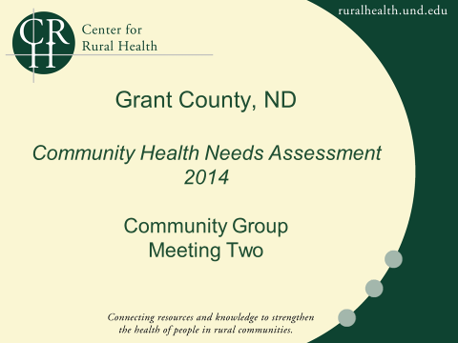

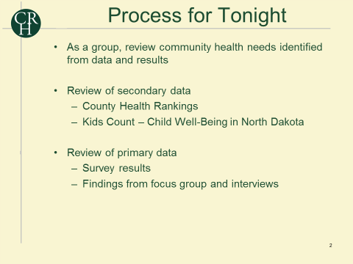
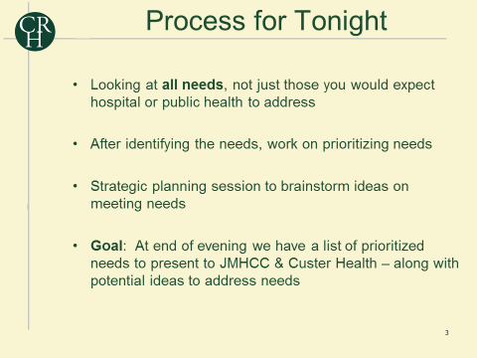

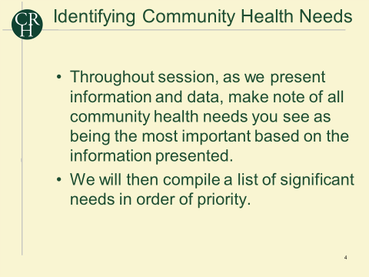
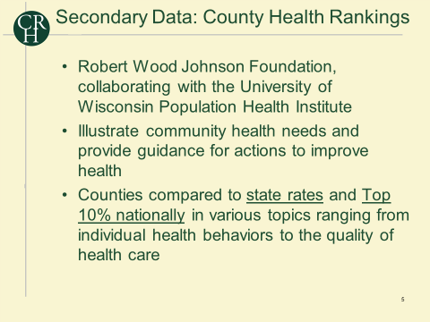

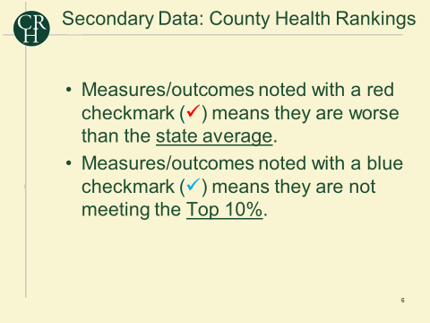
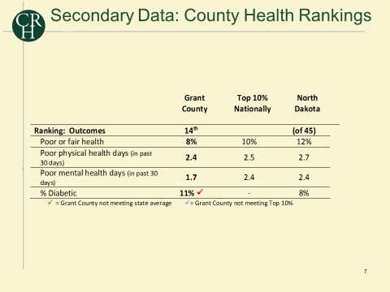

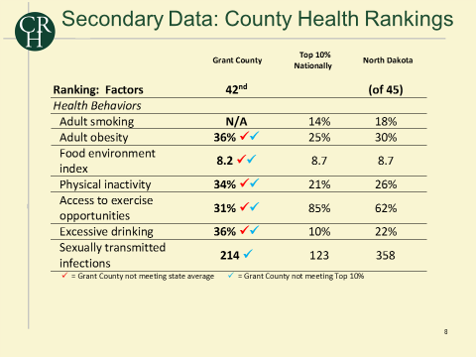
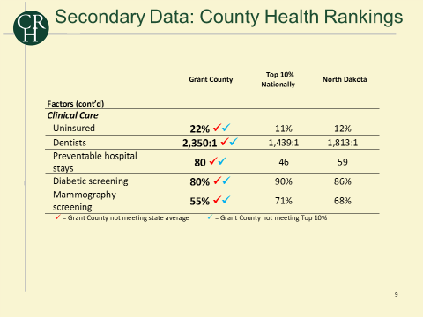

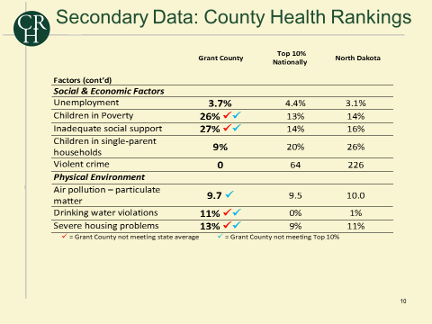
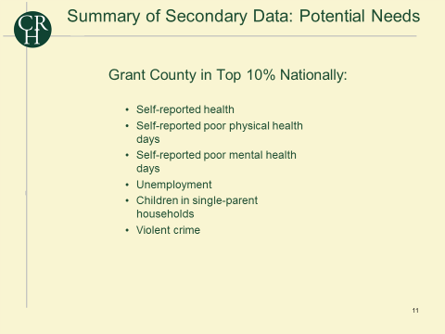

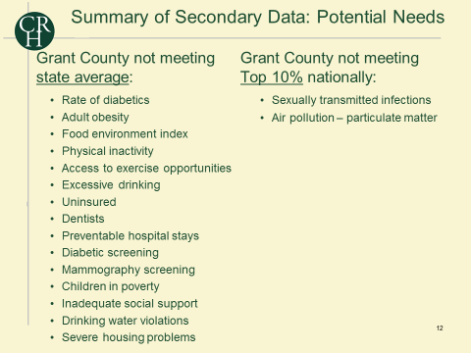
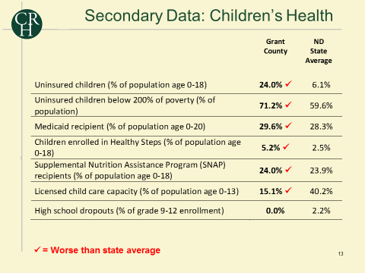

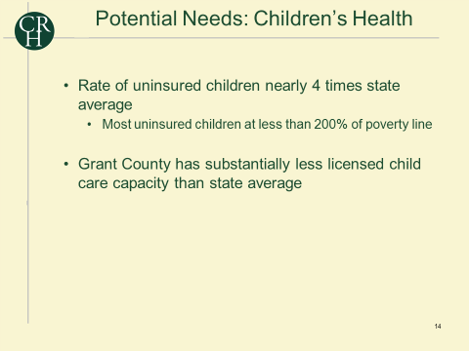

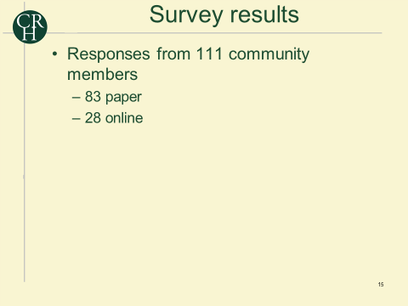

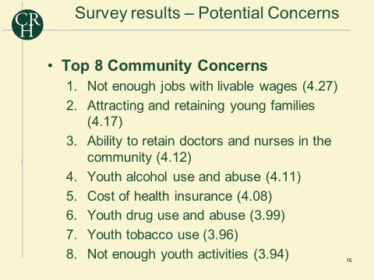
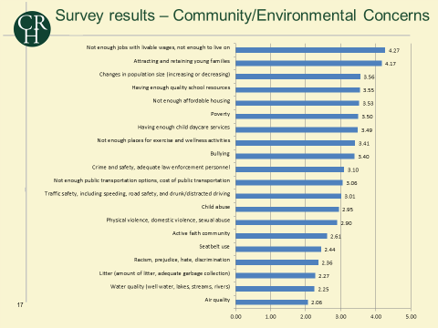

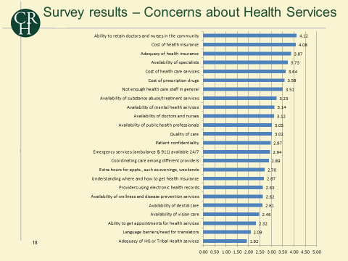
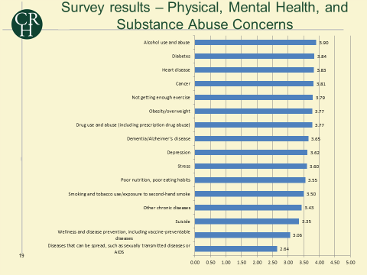

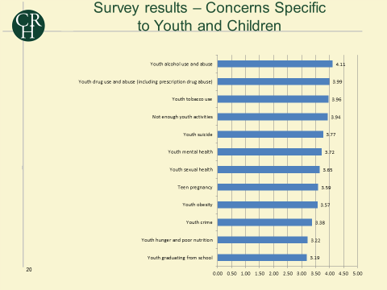
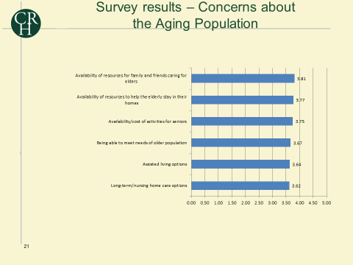

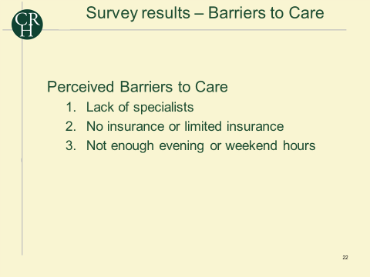

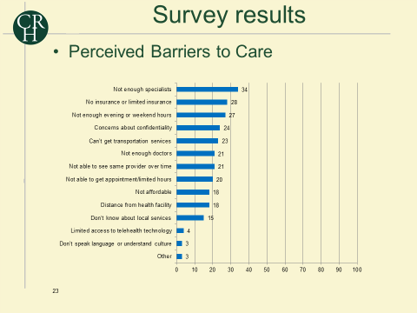

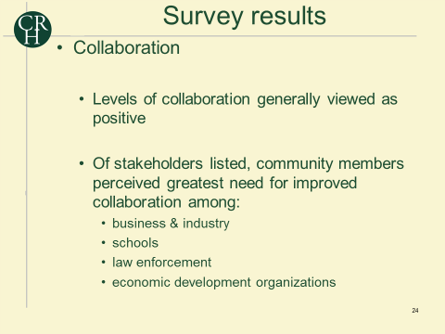
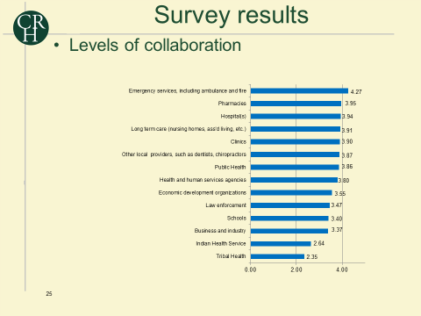

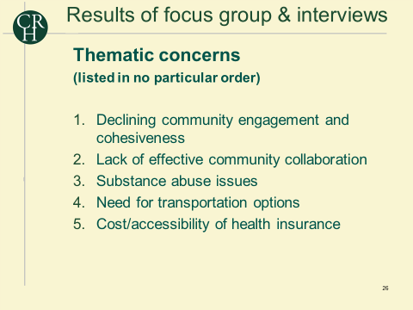

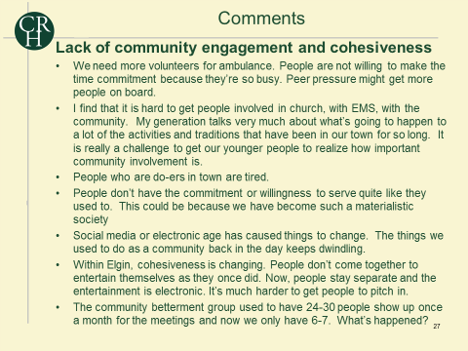

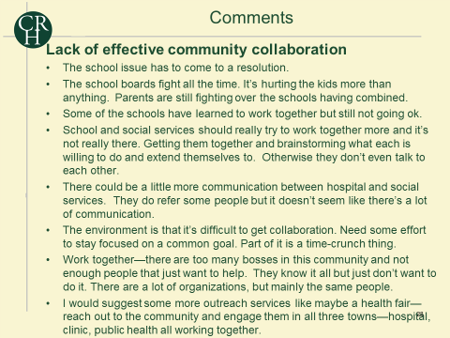
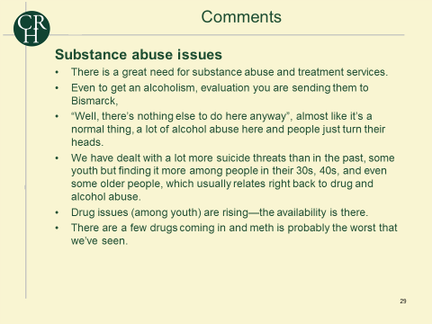
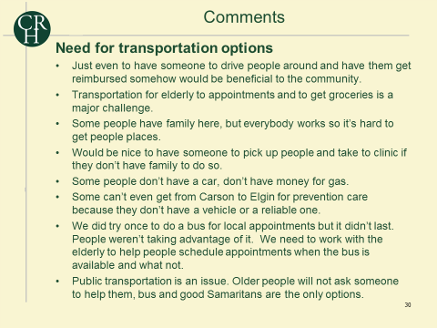

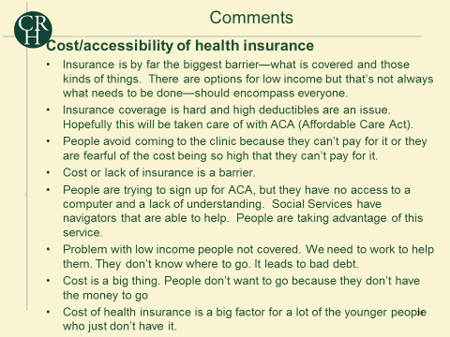

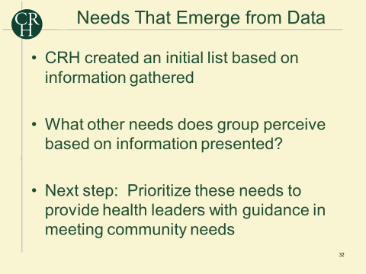
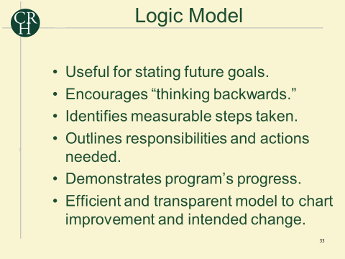

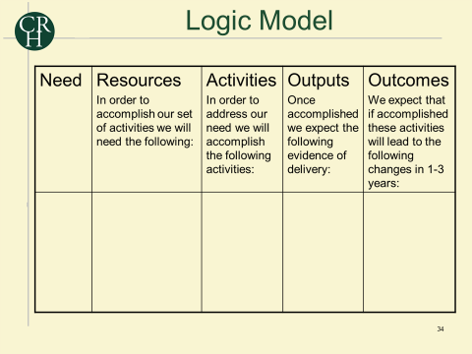
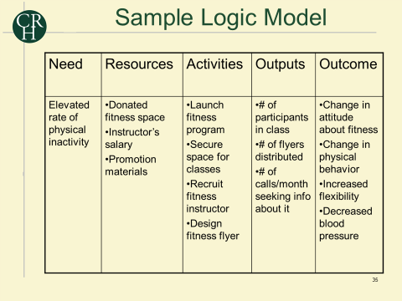

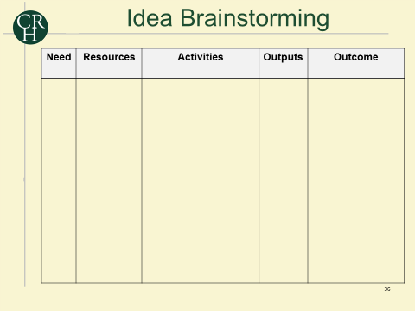
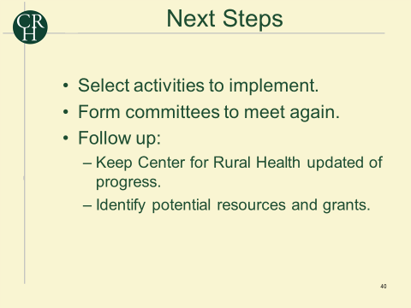
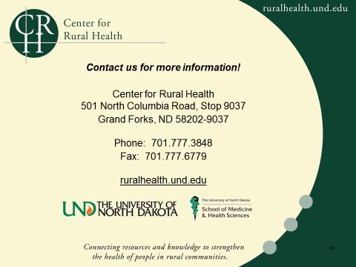

Appendix B: Brainstorming Documents

Need | Resources | Activities | Outputs | Outcome
Attracting and retaining young families |  | - Economic Development:  - Create a job development authority.  - Marketing the community as a “nice place” to raise a family. (bedroom community)  - Continuing to offer the “one-of-everything” – sustaining the current level of service.  - Educate the youth on the importance of “educating/ professionals” and come back to serve the community.  - Utilize the “young resources” in the community to attract more families.  - Explore more of the online degree programs through JMHCC.  - Re-establishing the “pride” in Grant County.  - SWOT analysis of where Grant County is at, and where it’s going – Strategic Plan for the County. | Number of children in kindergarten class  Increase in effort towards economic development | - Amount of children in the school populations  - Convenience store in town  - New apartment complex  - Jobs, housing, childcare  - Advertise and utilization of the pool  - Old building purchased by incoming business  - Increase in business and employment  - Oil boom hits Grant County  - Change in attitude to believe that “small towns are okay”  - Hospital meets the needs for all.  - Doctors available to provide care for youth.

Need | Resources | Activities | Outputs | Outcome
Healthy Lifestyles, Healthy Living (obesity, diabetes, physical inactivity) |  | - Fitness trails in the community  - Fitness in the home (education)  - Dietician or nutritionist providing education  - Bountiful baskets  - Finding something that makes the exercise activity “new” |  | - Built Environment  - Fitness center – community gym – high attendance.  - New bike path opens.  - Use of school pool increases.  - Activities  - Healthy activities increase across the lifespan  - Fitness classes  - Diabetes  - Diabetic educator hired  - Screenings offered  - Decrease in obesity rate

