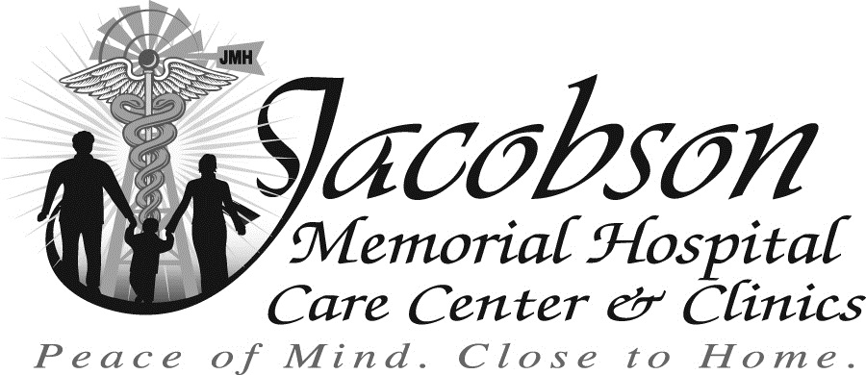

Are you loyal, driven, and compassionate?
Join our team of like-minded people.

Laundry Aide
1 Part-time; rotating Starting wage $11.59/hr, may increase based on experience.

Groundskeeper
16 hours/week; temporary. Primary job duties will be mowing lawn and tree maintenance. Starting wage $12.00/hr, may increase based on experience.

Dietary Aide/Cook
1 Part-time; rotating days and evenings, weekends and holidays. $3000 sign on bonus. Starting wage $12.36/hr, may increase based on experience.

Housekeeper
2 Full-time; rotating weekends and holidays. $3000 sign on bonus. Starting wage $12.36/hr, may increase based on experience.

Licensed Practical Nurse (LPN)
Enrich the lives of patients while choosing your own schedule in full-time or part-time LPN position. Eligible for $25,000 student loan repayment and $5,000 sign-on bonus. Starting wage $22.66/hr, may increase based on experience.

Registered Nurse (RN)
Make a difference and gain valuable experience as a full-time or part-time charge nurse at JMHCC! This position is eligible for a $5,000 sign on bonus and $25,000 student loan repayment program. Starting wage $29.36/hr, may increase based on experience.

Certified Nurse Assistant (CNA)
Support and empower patients through hands-on care in a meaningful CNA role at Jacobson Memorial Hospital. CNA certification required, but we can assist you in obtaining certification if necessary. Full-time or part-time positions are available. These positions are eligible for a $4,000 sign on bonus. Starting wage $17.00/hr, may increase based on experience.

All full-time and part-time positions are eligible for our competitive benefits package.
Contact Kristin at (701) 584-7247 or kheid@jmhcc.org to apply.
JMHCC is an equal opportunity employer.

